**Phase 2**

**Salesforce Edition**

• **Development Environment:**

1. The project is being built within a **free Salesforce Developer Edition**.
2. This edition is selected because it provides access to **Enterprise Edition features** (such as Flows, Custom Objects, and Apex) but with restricted capacity (limited users, storage).

• **Target Production Environments (for Launch):**

1. A commercial edition, typically **Enterprise** or **Unlimited**, would be required to scale the "RentEase" application for live business use.
2. These editions offer the necessary **high user limits, robust API access**, and **larger data storage** capacity for a full-scale property management solution.

• **Key Takeaway:** The current environment is solely for **building and testing** the feature set.

**Company Profile Setup Details**

* **Organizational Identity:**
  + The formal **Organization Name** has been set to **RentEase**.
  + The official headquarters address Jabalpur and contact information is email [siddhes99@gmail.com](mailto:siddhes99@gmail.com) and phone is 8305218612.

**Time & Location Standards:**

* + The **Indian Locale** is configured to establish correct formatting standards for dates, times, and currency.
  + The **Indian Ruppee Currency** is set based on the organization's financial region.

**Financial & Service Defaults:**

* + The project uses a **Standard Fiscal Year** with a defined start month (e.g., January) to ensure accurate financial reporting consistency.
  + Specific **Business Hours** are now defined and will be used as a baseline for measuring response and resolution times for maintenance service processes.

\

**Company Profile Setup Implementation**

* **1. Access Company Information:**
  + **Step:** Click the **gear icon** and navigate to **Setup**.
  + **Step:** Use Quick Find to search for and select Company Information.

**2. Update Organization Details:**

* + **Step:** Click the **Edit** button on the Company Information page.
  + **Step:** Update the **Organization Name** to **RentEase**.
  + **Step:** Fill in the primary **Address**, **Phone**, and verify .

**3. Set Fiscal Year:**

* + **Step:** Navigate to the **Fiscal Year** settings from the Company Information page.
  + **Step:** Select **Standard Fiscal Year**.
  + **Step:** Choose the specific **month** your company's financial year.

**4. Define Business Hours:**

* + **Step:** Use Quick Find to search for and select Business Hours.
  + **Step:** Click **New** or **Edit** the existing default entry.
  + **Step:** Define the standard work week hours.

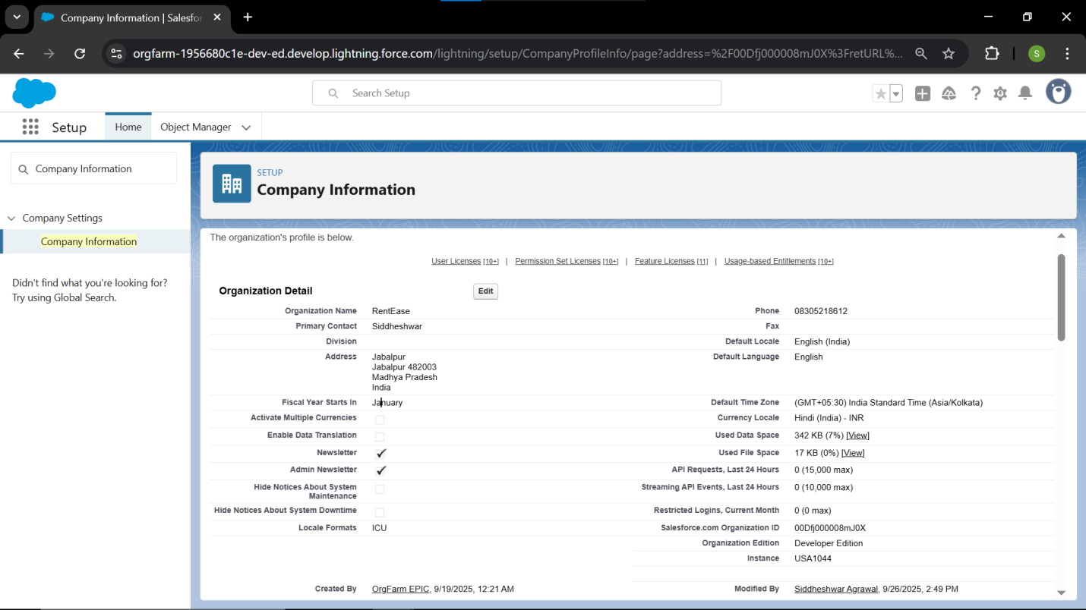

**Business Hours & Holidays**.

* **Business Hours Definition:**
  1. A dedicated **Business Hours record** (RentEase Standard Hours) has been created to define the active working schedule ( Monday to Friday, 10:00 AM - 6:00 PM).
  2. This definition ensures that time-based automation only counts time when staff are available.
* **Holidays Integration:**
  1. All relevant company holidays have been entered into the system.
  2. The system is configured so that time-based calculations (e.g., tracking how long a maintenance request has been open) automatically **pause** during these specified holidays.

• **1. Access Business Hours:**

* **Step:** Click the **gear icon** and navigate to **Setup**.
* **Step:** Use Quick Find to search for and select Business Hours.

• **2. Define Standard Business Schedule:**

* **Step:** Click **New** or **Edit** the existing **Default** entry.
* **Step:** Set the **Label** ( RentEase Standard Hours).
* **Step:** Define the days and specific **Start and End Times** for your property management office (e.g., Monday through Friday, 10:00 AM - 6:00 PM).
* **Step:** Ensure the correct **Time Zone** is selected.
* **Step:** Click **Save**.

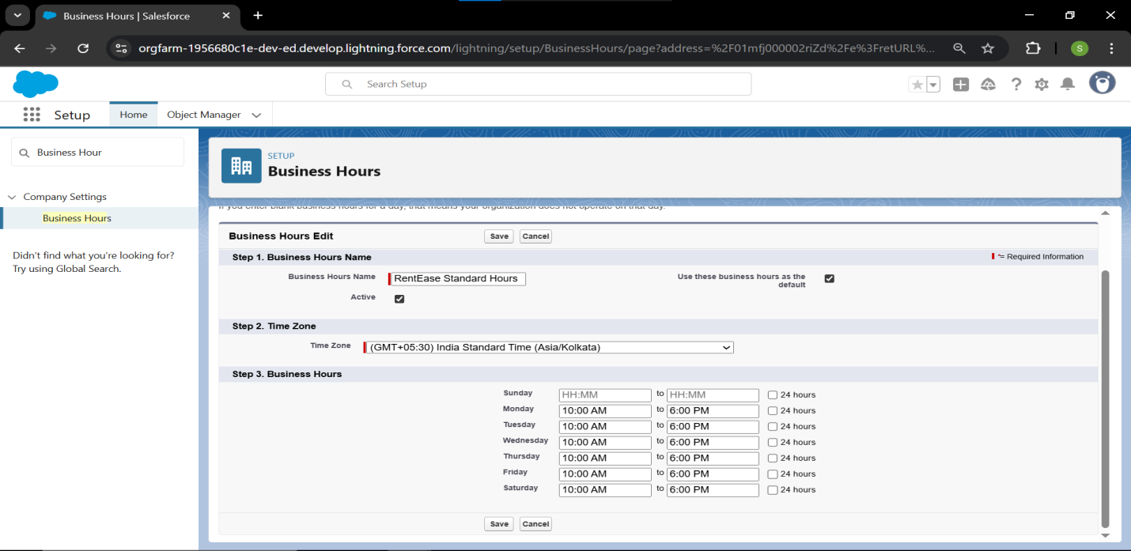

* **3. Access Holidays:**
  + **Step:** Use Quick Find to search for and select Holidays.
* **4. Enter Company Holidays:**
  + **Step:** Click **New**.
  + **Step:** Enter the **Name** of the holiday .
  + **Step:** Select the specific **Date** of the holiday.
  + **Step:** Mark if the holiday is **Recurring**
  + **Step:** Click **Save**.
  + **Step:** **Repeat** this process to enter all necessary annual company holidays.

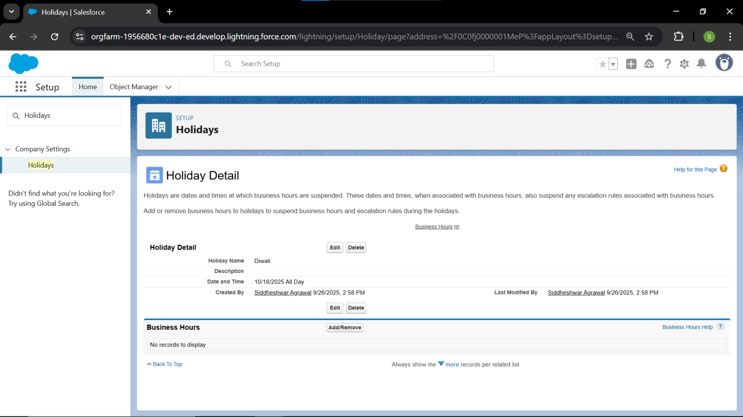

**Fiscal Year Settings:**

* **Primary Objective:** To define the annual financial reporting cycle within Salesforce to ensure alignment with the Finance Team's accounting standards.
* **Fiscal Year Type:**
  1. The system is configured to use a **Standard Fiscal Year**.
  2. This choice maintains a straightforward 12-month accounting period.
* **Start Month Defined:**
  1. The fiscal year is defined to begin on the first day of **[Insert Month Here January]**.
  2. This setting will govern the grouping and labeling of financial data in all reports and dashboards

**Fiscal Year Settings:**

* **1. Access Fiscal Year Settings:**
  + **Step:** Click the **gear icon** and navigate to **Setup**.
  + **Step:** Use Quick Find to search for and select Fiscal Year.
* **2. Choose Fiscal Year Type:**
  + **Step:** Confirm that **Standard Fiscal Year** is selected.
* **3. Define Start Month:**
  + **Step:** Select the specific **Start Month** for your company's fiscal year (choose January).
  + **Step:** Select the **Yearly Period** (12 Months).
  + **Step:** Click **Save**.

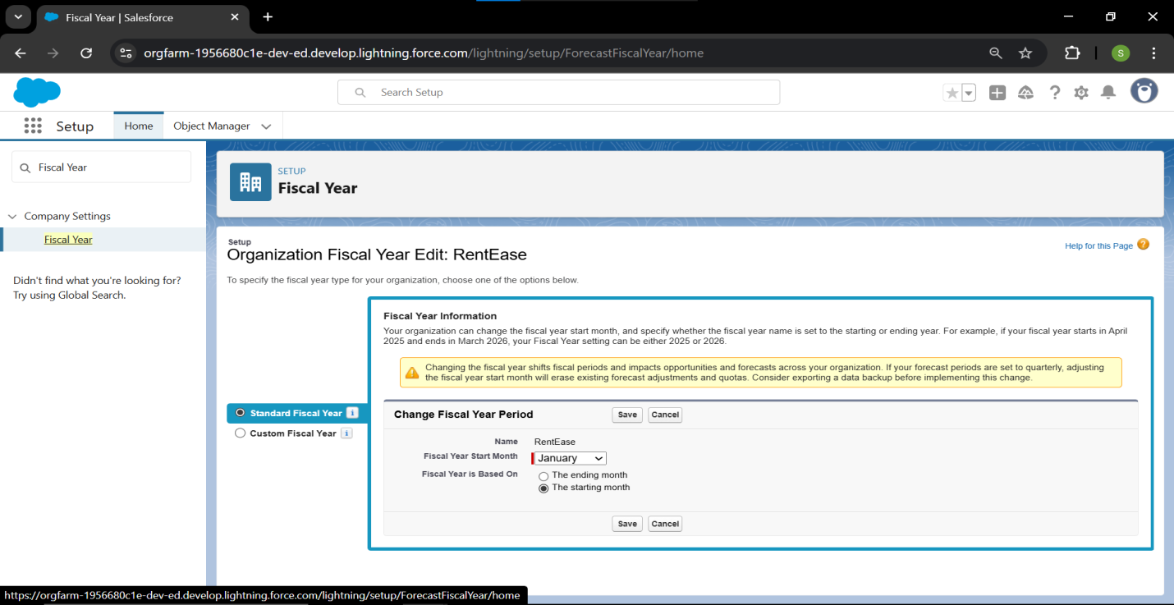

**User Setup & Licenses:**

* **Primary Objective:** To provision all necessary internal staff accounts and establish the mandatory link between the user, their specific **Profile**, and their position in the **Role Hierarchy**.
* **Internal User Allocation:**
  1. Four primary internal user accounts were provisioned: Admin/CEO, Property Manager, Finance Team, and Maintenance Staff.
  2. Each user is assigned to their corresponding custom Profile and a specific Role within the RentEase hierarchy.
* **License Management:**
  1. The **Salesforce User License** was allocated to primary administrators.
  2. The **Salesforce Platform License** was utilized for specialized staff (Finance/Maintenance) to optimize license usage.
* **Tenant User Note:**
  1. External tenant accounts were **not** created in this step.
  2. Tenant users will be provisioned later as **Experience Cloud Users**.

**User Setup & Licenses:**

* **1. Access User Management:**
  + **Step:** Click the **gear icon** ⚙️ and navigate to **Setup**.
  + **Step:** Use Quick Find to search for and select Users, then click **Users**.
* **2. Create Admin/CEO User:**
  + **Step:** Click the **New User** button.
  + **Step:** Fill in a valid **Name** and a unique **Username** (e.g., manager.rentease@example.com).
  + **Step:** Set **User License** to **Salesforce**.
  + **Step:** Set **Profile** to **System Administrator** (or the Profile that has been designated as your initial highest admin).
  + **Step:** Set **Role** to **RentEase CEO**.
  + **Step:** Click **Save**.
* **3. Create Property Manager User:**
  + **Step:** Click **New User**.
  + **Step:** Set **User License** to **Salesforce**.
  + **Step:** Set **Profile** to **RentEase Property Manager**.
  + **Step:** Set **Role** to **RentEase Property Manager**.
  + **Step:** Click **Save**.
* **4. Create Finance Team User:**
  + **Step:** Click **New User**.
  + **Step:** Set **User License** to **Salesforce Platform** (or Salesforce if available).
  + **Step:** Set **Profile** to **RentEase Finance Team**.
  + **Step:** Set **Role** to **RentEase Finance Team**.
  + **Step:** Click **Save**.
* **5. Create Maintenance Staff User:**
  + **Step:** Click **New User**.
  + **Step:** Set **User License** to **Salesforce Platform**.
  + **Step:** Set **Profile** to **RentEase Maintenance Staff**.
  + **Step:** Set **Role** to **RentEase Maintenance Staff**.
  + **Step:** Click **Save**.

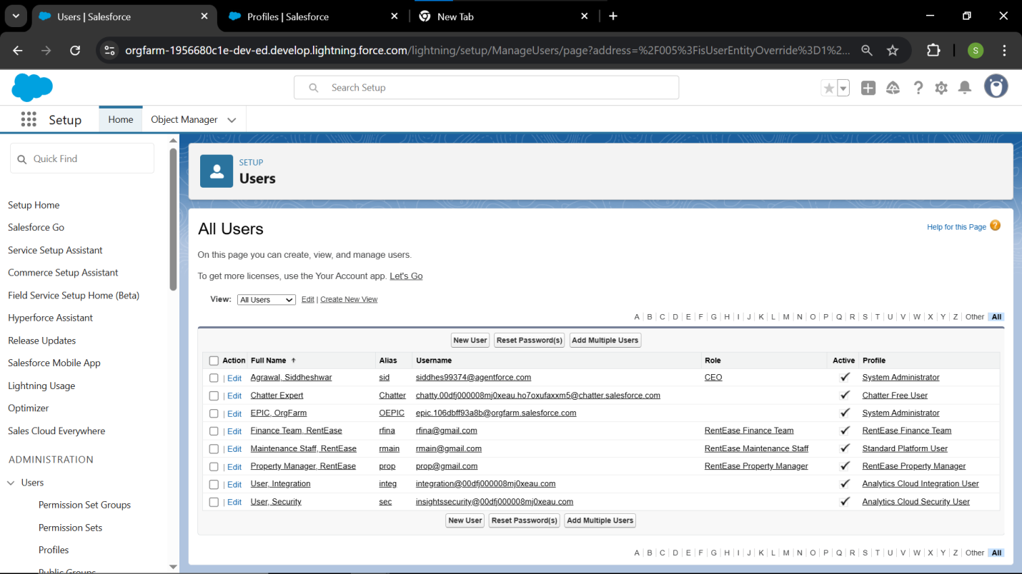

*.*

**Profiles:**

* **Total Profiles Created:** Four custom profiles were created to enforce the security model.
* **Profile Types and Licensing:**
  1. The **RentEase Property Manager** profile was cloned from **Standard User**, compatible with the **Salesforce License**.
  2. The **RentEase Finance Team**, **Maintenance Staff**, and **Tenant** profiles were cloned from a Platform license base, compatible with the **Salesforce Platform License** for cost efficiency.
* **Permission Summary (CRUD/Object Level):**
  1. **Manager:** Granted **Full CRUD access** on all custom objects for complete administrative oversight.
  2. **Finance Team:** Granted **Read/Edit** on **Lease** and **Payment** objects for financial reconciliation purposes.
  3. **Maintenance Staff:** Granted **Read/Edit** on **Maintenance Request** only, with Read access to **Property** and **Tenant** for context.
  4. **Tenant:** Granted highly restricted access to only **Read** their own Lease/Payment data and **Create/Read** their own Maintenance Requests.

### Profiles: Implementation

#### 1. Create the Manager Profile

* **Step:** Go to **Setup** → Profiles. Find the **Standard User** profile.
* **Step:** Click **Clone**.
* **Step:** Name the new profile **RentEase Property Manager**.
* **Step:** Click **Edit** on the new profile.
* **Step:** Scroll to **Custom Object Permissions**.
* **Action:** For **ALL 7 Custom Objects** (Property, Lease, Tenant, Payment, Maintenance Request, Staff/User, Notification Log), check all boxes for **Read**, **Create**, **Edit**, and **Delete**.
* **Step:** Click **Save**.

#### 2. Create the Finance Team Profile

* **Step:** Go back to the Profiles list and find the **Standard Platform User** profile.
* **Step:** Click **Clone** (or clone the existing **RentEase Maintenance Staff** profile).
* **Step:** Name the new profile **RentEase Finance Team**.
* **Step:** Click **Edit** and scroll to **Custom Object Permissions**.
* **Action:** Set permissions for financial oversight:
  + **Lease:** Check **Read** and **Edit**.
  + **Payment:** Check **Read** and **Edit**.
  + **Tenant:** Check **Read** only.
  + **All Other Objects:** Leave as **No Access**.
* **Step:** Click **Save**.

#### 3. Create the Tenant Profile

* **Step:** Clone a **Standard Platform User** profile (or clone your new Finance profile).
* **Step:** Name the new profile **RentEase Tenant**.
* **Step:** Click **Edit** and scroll to **Custom Object Permissions**.
* **Action:** Set permissions for self-service:
  + **Maintenance Request:** Check **Read** and **Create**.
  + **Property:** Check **Read** only.
  + **Lease:** Check **Read** only.
  + **Payment:** Check **Read** only.
  + **All Other Objects:** Leave as **No Access**.
* **Step:** Click **Save**.

#### 4.User Creation and Assignment

* **Step:** Go to **Setup** → Users → **New User**.
* **Step:** Fill in the user's name and a unique email/username.
* **Action:** Set the **User License** to **Salesforce Platform** (this is essential for the profile to appear).
* **Action:** Set the **Profile** to **RentEase Maintenance Staff**.
* **Action:** Set the **Role** to **RentEase Maintenance Staff**.
* **Step:** Click **Save**.

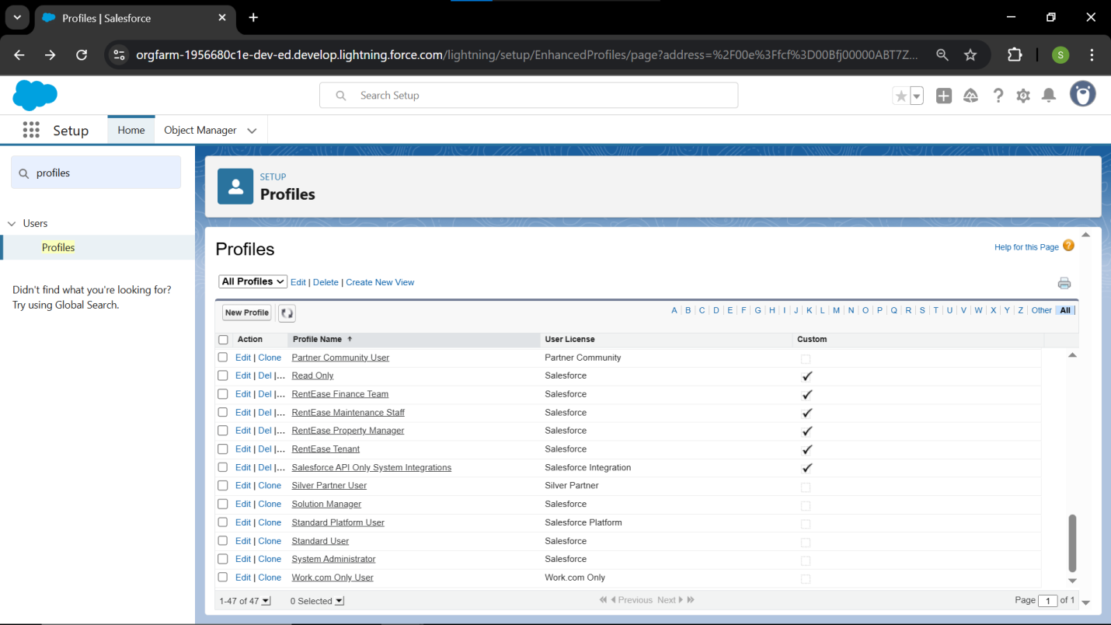

**Roles:**

* **Primary Objective:** To define the organizational structure necessary for the OWD (Private) model, enabling data access through the management chain.
* **Hierarchy Structure:**
  1. A **four-tier hierarchy** was established, starting with **RentEase CEO** at the top.
  2. The **RentEase Property Manager** is the primary operational manager.
  3. **Finance, Maintenance, and Tenant** roles are positioned as subordinates to the Property Manager.
* **Sharing Impact:**
  1. This structure ensures that the **Property Manager** automatically gains **Read Access** to all records owned by users in the Finance, Maintenance, and Tenant roles.
  2. This is a critical component of the security model, as it works in tandem with the **OWD Private** settings.

### Roles: Implementation

#### 1. Access Role Management

* **Step:** Click the **gear icon** and navigate to **Setup**.
* **Step:** Use Quick Find to search for and select Roles.
* **Step:** Click **Set Up Roles** to view the hierarchy tree.

#### 2. Create the Role Hierarchy (Top-Down)

* **Step:** Create the **RentEase CEO** role first. Find the top-most role and click **Add Role** below it. Set **Reports To** as **(Self Report)**.
* **Step:** Find the new **RentEase CEO** role and click **Add Role** below it. Create the **RentEase Property Manager** role, setting **Reports To** as **RentEase CEO**.
* **Step:** Find the **RentEase Property Manager** role and click **Add Role** below it three times to create the subordinate roles:
  1. **RentEase Finance Team** (Reports to Manager)
  2. **RentEase Maintenance Staff** (Reports to Manager)
  3. **RentEase Tenant** (Reports to Manager)

#### 3. Assign Users to Roles

* **Step:** Click the **Assign Users to Roles** button (or navigate to the role you want to assign).
* **Step:** Assign the corresponding user to each role you created (e.g., assign the Property Manager user to the **RentEase Property Manager** role).
* **Step:** Click **Save**.

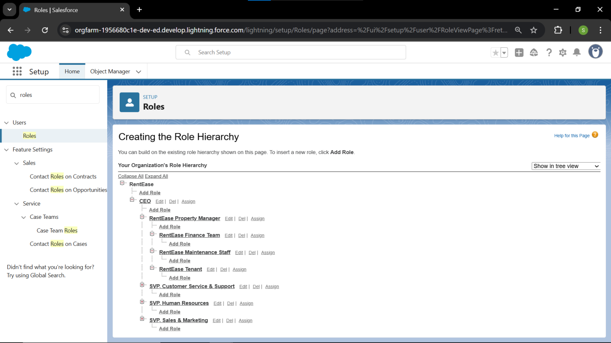

**Permission Sets:**

* **Primary Objective:** To grant necessary reporting access that intentionally overrides the strict **OWD Private** security model without altering the base user Profiles.
* **Set Details:**
  1. The **Advanced Reporting** Permission Set was created specifically for management and financial oversight roles.
  2. This set adheres to the principle of granting **additional access** beyond the user's base Profile.
* **Permissions Granted:**
  1. The set grants the crucial **View All** access on both the **Property** and **Lease** custom objects.
  2. This ensures Property Managers and the Finance Team can see **every record** regardless of ownership, which is essential for accurate, system-wide dashboards and reporting.

### Permission Sets: Implementation

#### 1. Create the Permission Set

* **Step:** Click the **gear icon** and navigate to **Setup**.
* **Step:** Use Quick Find to search for and select Permission Sets.
* **Step:** Click the **New** button.
* **Step:** Set the **Label** to **Advanced Reporting**.
* **Step:** Click **Save**.

#### 2. Set Object Permissions

* **Step:** On the new Permission Set detail page, scroll down to the **Apps** section and click on **Object Settings**.
* **Action:** Click on the **Property** object in the list.
* **Action:** Click **Edit**, ensure **Read** is checked, and check the box for **View All** under **Object Permissions**.
* **Step:** Click **Save**.
* **Step:** Return to **Object Settings** and repeat the process for the **Lease** object, granting **View All** permission.

#### 3. Assign Permission Set to Users

* **Step:** From the **Advanced Reporting** detail page, click the **Manage Assignments** button.
* **Step:** Click **Add Assignments**.
* **Action:** Select the actual user records for the **RentEase Property Manager** and the **RentEase Finance Team** (the users you created in the User Setup step).
* **Step:** Click **Assign**, then **Done**.

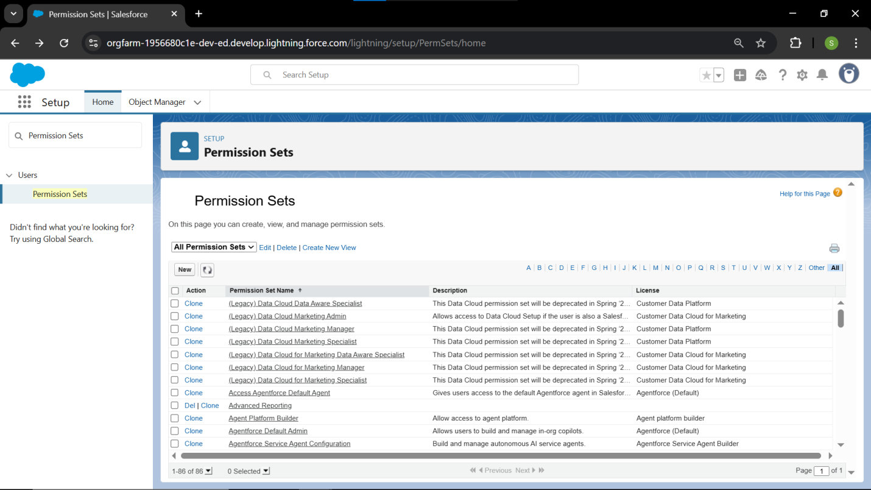

**OWD (Organization-Wide Defaults):**

* **Primary Objective:** To establish the highest level of record-level security across the organization, following the best practice of starting with the most restrictive setting.
* **Security Setting Applied:**
  1. The **Private** sharing model was applied to all core custom objects (Property, Lease, Tenant).
  2. This ensures that by default, a user can only access records they **own** or records owned by subordinates in the **Role Hierarchy**.
* **Impact on Security Model:**The OWD Private setting makes the established **Role Hierarchy** and the creation of **Sharing Rules** mandatory for granting necessary business access exceptions.

**OWD (Organization-Wide Defaults): Implementation**

* **1. Access Sharing Settings:**
  + **Step:** Click the **gear icon** and navigate to **Setup**.
  + **Step:** Use Quick Find to search for and select Sharing Settings.
* **2. Enter Edit Mode:**
  + **Step:** Find the **Organization-Wide Defaults** section.
  + **Step:** Click the **Edit** button.
* **3. Configure Default Access (The Private Baseline):**
  + **Action:** For all of your custom objects: **Property, Tenant, Lease, Maintenance Request, Staff/User,** and **Notification Log**.
  + **Action:** Set the **Default Internal Access** dropdown to **Private**.
  + **Detail:** Confirm the **Payment** object automatically shows **Controlled by Parent**.
  + **Action:** Set the **Default External Access** dropdown to **Private** for all custom objects.
* **4. Save Changes:**
  + **Step:** Click **Save**. The system will start recalculating sharing access.

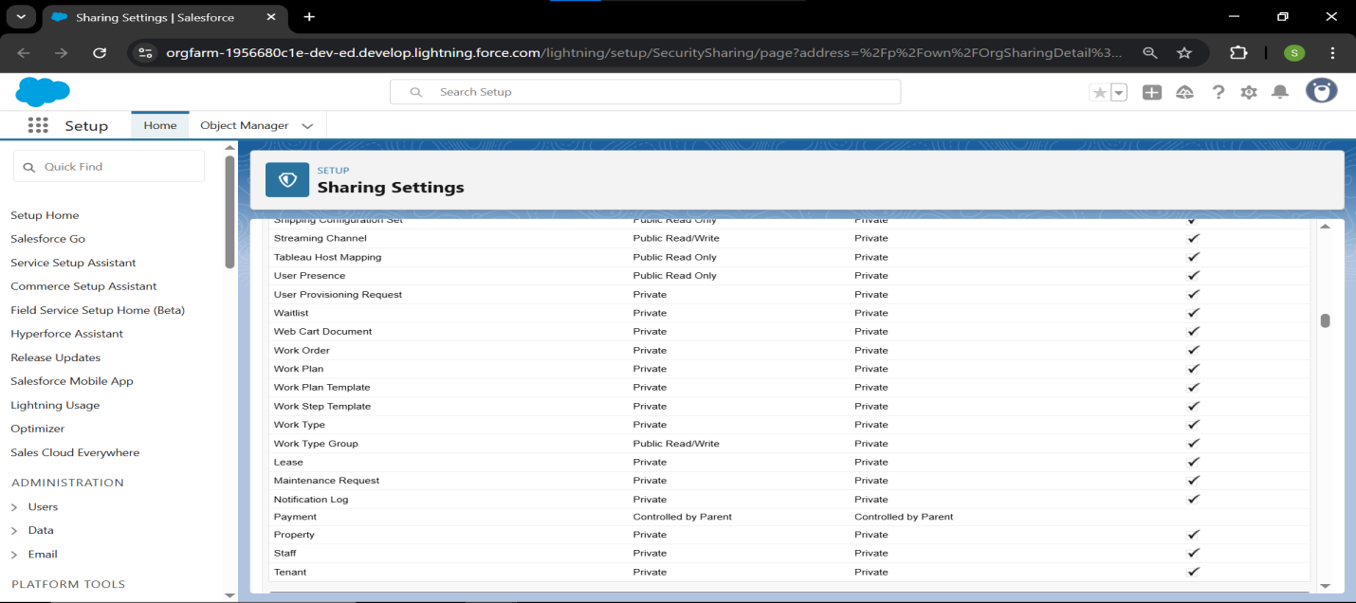

**Sharing Rules:**

* **Primary Objective:** To create necessary exceptions to the OWD Private model, ensuring cross-functional visibility is granted only where required by the business process.
* **Rule 1: Financial Oversight (Lease Object):**
  1. **Type:** Criteria-Based Sharing Rule.
  2. **Purpose:** Provides the Finance Team with **Read Only** access to all active Lease records.
  3. **Result:** This access automatically extends to the child **Payment** records (due to **Controlled by Parent** OWD), fulfilling the reconciliation requirement.
* **Rule 2: Service Collaboration (Maintenance Request Object):**
  1. **Type:** Owner-Based Sharing Rule.
  2. **Purpose:** Grants the **Maintenance Staff** role **Read/Write** access to all requests owned by the **Tenant** role.
  3. **Result:** Enables the staff to view and update the status of any open request, streamlining the service workflow

### Sharing Rules: Implementation

* **1. Access Sharing Settings:**
  + **Step:** Click the **gear icon** and navigate to **Setup**.
  + **Step:** Use Quick Find to search for and select Sharing Settings.
  + **Step:** Scroll down to the **Sharing Rules** section.

#### 2. Rule 1: Share Leases with Finance Team

* **Goal:** Allow the Finance Team to see all Lease and associated Payment records.
* **Step:** Find the **Lease Sharing Rules** section and click **New**.
* **Step:** **Rule Name:** Share Leases with Finance
* **Step:** **Rule Type:** Select **Based on Criteria**.
* **Action:** Define the criteria: **Field:** Lease Status **Operator:** not equal to **Value:** Canceled. (This includes all active/pending leases).
* **Action:** **Share With:** Select **Roles and Subordinates** → **RentEase Finance Team**.
* **Action:** **Access Level:** Set to **Read Only**.
* **Step:** Click **Save**.

#### 3. Rule 2: Share Maintenance Requests

* **Goal:** Allow the Maintenance Staff to see all requests submitted by Tenants.
* **Step:** Find the **Maintenance Request Sharing Rules** section and click **New**.
* **Step:** **Rule Name:** Share All Maintenance Requests
* **Step:** **Rule Type:** Select **Based on Record Owner**.
* **Action:** **Records Owned By:** Select **Roles and Subordinates** → **RentEase Tenant** role.
* **Action:** **Share With:** Select **Roles and Subordinates** → **RentEase Maintenance Staff** role.
* **Action:** **Access Level:** Set to **Read/Write** (so staff can update the status).
* **Step:** Click **Save**.

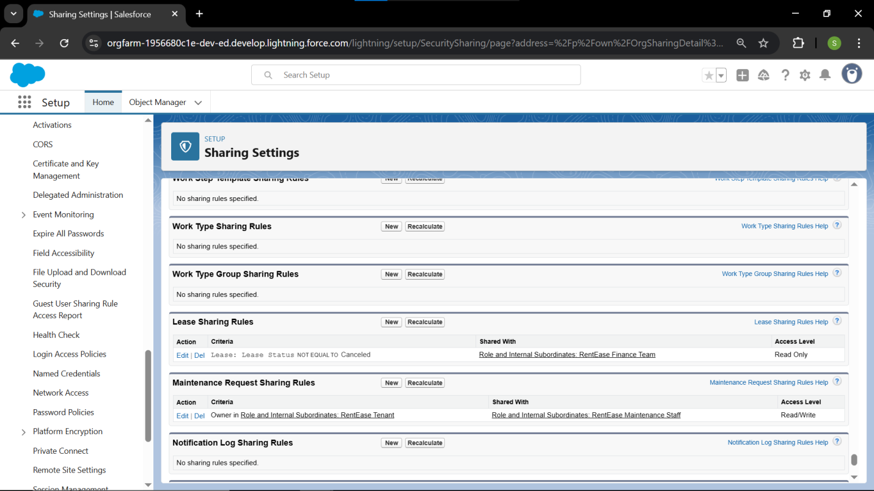

**Login Access Policies:**

* **Primary Objective:** To control and audit the ability of administrators and external parties to access user accounts for support and maintenance purposes.
* **Internal Policy:**
  1. The setting **"Administrators Can Log In as Any User"** is **enabled**.
  2. This policy is essential for the Admin and Property Manager roles to troubleshoot security, permissions, and user-reported issues without requiring passwords.
* **External Policy:**
  1. Access for **External Service Providers** (Salesforce support, partners) is currently **disabled**.
  2. This adheres to a high-security posture, ensuring no external party can access the org without explicit, temporary authorization.

**Login Access Policies: Implementation**

* **1. Access Login Access Settings:**
  + **Step:** Click the **gear icon** and navigate to **Setup**.
  + **Step:** Use Quick Find to search for and select Login Access Policies.
* **2. Configure Internal Admin Access:**
  + **Action:** Review the setting for **Administrators Can Log In as Any User**.
  + **Action:** Ensure this box is **checked**.
  + **Detail:** This permission allows System Administrators (or users with specific permissions, like the Property Manager) to log in as a Tenant or Maintenance Staff user to test permissions or troubleshoot an issue directly.
  + **Step:** Click **Save** if you made a change.

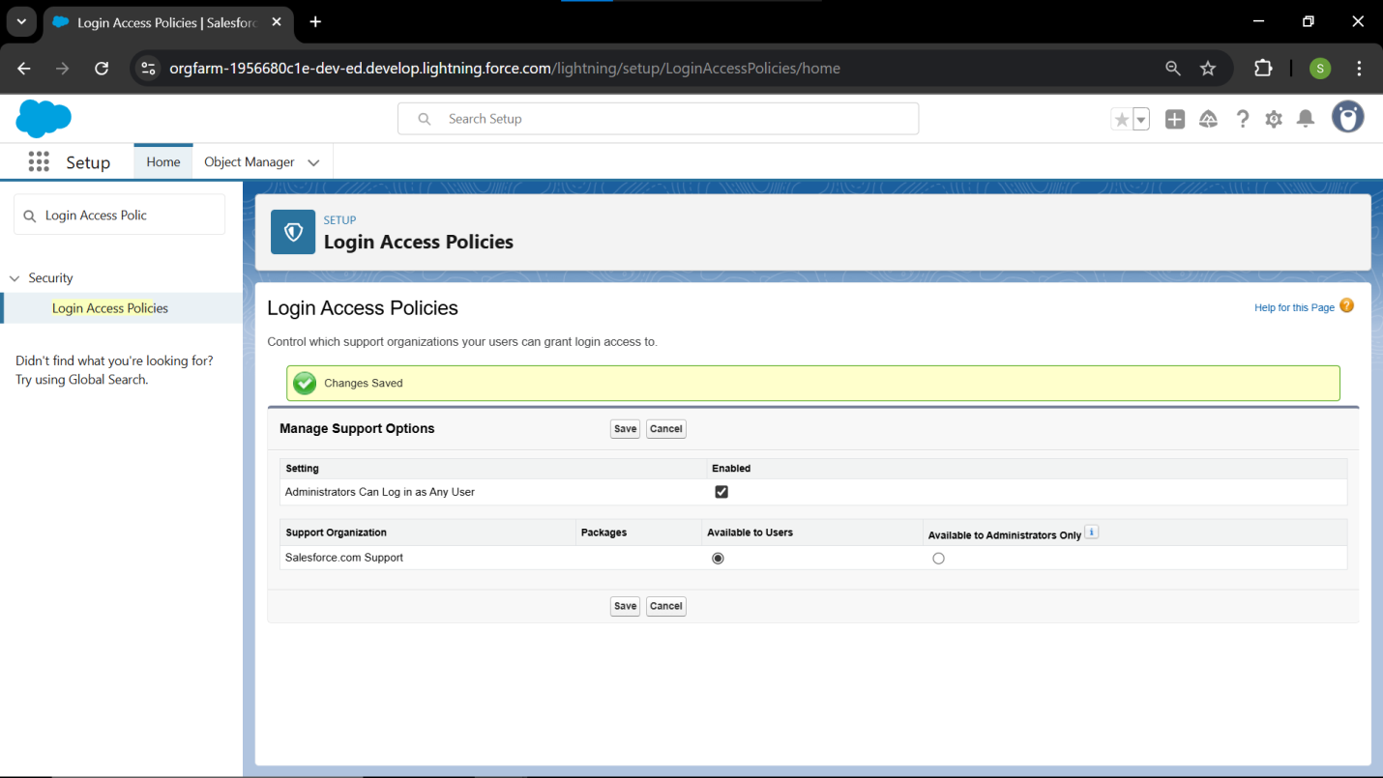

**Dev Org Setup:**

* **Primary Objective:** To configure the core developer instance, ensuring tools are available and a standardized development environment is established.
* **Development Environment:**
  1. The primary development is housed in a clean **Developer Edition** instance.
  2. This instance provides **full configuration access**.
* **Project Tools:**
  1. **VS Code and Salesforce CLI (SFDX)** are established as the mandatory tools for **metadata management** and **Apex/LWC development**.
* **Application Container:**
  1. The core application, **RentEase (Lightning App)**, has been created.
  2. This App is the unified interface where all users will access the system, and it has been assigned visibility to all custom internal profiles.

**Dev Org Setup: Implementation Steps 🛠️**

* **1. Verify Environment & License:**
  + **Step:** Go to **Setup** → Company Information.
  + **Step:** Verify that the **Organization Edition** is **Developer Edition**.
  + **Detail:** This confirms you have the necessary features for the entire project lifecycle.
* **2. Establish Naming Convention (Best Practice):**
  + **Step:** Define a standard prefix for all components
  + **Detail:** This ensures all custom components are easily identifiable and don't conflict with standard Salesforce names.
* **3. Create the Main Lightning App:**
  + **Step:** Use Quick Find to search for and select App Manager.
  + **Step:** Click **New Lightning App**.
  + **Action:** Name the app **RentEase**. Choose a brand image/color.
  + **Action:** Set the **User Profiles** that can see the app
  + **Step:** Click **Save and Finish**.
* **4. Tools Checklist:**
  + **Step:** Ensure you have **Visual Studio Code (VS Code)** installed.
  + **Step:** Ensure the **Salesforce Extension Pack** is installed within VS Code.
  + **Step:** Ensure the **Salesforce CLI** is installed and authorized for this Org